
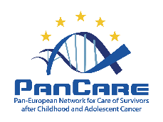
This Care Plan is developed within
Clinic logo
PanCare Transition of Care Plan
This PanCare Transition of Care Plan is designed to support you through key moments in your healthcare journey after paediatric or young adult cancer. This document provides you with a clear overview of the entire transition process and offers a structured, step-by-step, personalized guide and discussion topics. It helps you feel more informed, more in control, and confident.
You can use this plan in several ways, as a personal reference, a communication tool with your healthcare team, or as an accessible overview to help you navigate the transition process. Ideally, this plan is introduced early by your care team and regularly updated throughout the process: starting at the end of active treatment, until after the transfer moment to a new care setting. This plan contains personal and health information. It is kept by you, once completed. It can be shared with your healthcare provider, relatives, or caregivers, after your consent.
For detailed information about your past treatment, recommended long-term follow-up care, and general health recommendations, please use the PanCare Survivorship Care Plan – Long Version or Short Version.
Please note that this PanCare Transition of Care Plan is also available in other languages, which can be found on the PanCare website. The PanCare Transition of Care Plan may be updated in the future.
Date of development: May 2026
More information: www.pancare.eu
1. General information
2. Overview of the transition process
3. Overview of healthcare providers
4. Personal needs and wishes
5. Topics to discuss
6. Readiness assessment

 | Co-funded by the European Union. Views and opinions expressed are however those of the author(s) only and do not necessarily reflect those of the European Union or the European Health and Digital Executive Agency (HaDEA). Neither the European Union nor the granting authority can be held responsible for them.

- General information
This part describes your basic information.
(preferred) name | Enter name
Date of birth | DD/MM/YYYY
Sex at birth | Enter sex at birth
Gender identity | Enter gender identity
Telephone number | Enter telephone number
E-mail address | Enter e-mail address
Names of parents/caregivers | Enter names of parents/caregivers
Emergency contact person | Enter emergency contact person
Treatment centre | Enter treatment centre
General practitioner | Enter general practitioner

2. Overview of the transition process
This part provides an overview of the transition process around major transfer moments within the healthcare trajectory after paediatric or young adult cancer.
Around five years after diagnosis is often considered an important moment to move to long-term follow-up (LTFU) care. From that moment on, the focus of care typically shifts from monitoring for cancer recurrences and acute effects of cancer treatment to identifying and managing late effects of cancer therapy. Depending on your age at diagnosis, this moment may precede or coincide with the transfer to adult care. Ideally, these transfer moments should take place when you are ready for that actual transfer, meaning at a time of relative stability in terms of health, education, family circumstances, etc. The full process of adequate preparation for entering a new phase in care is referred to as the transition process. In the figure below, you can add (expected) dates of when transfer moments take place in your healthcare trajectory.

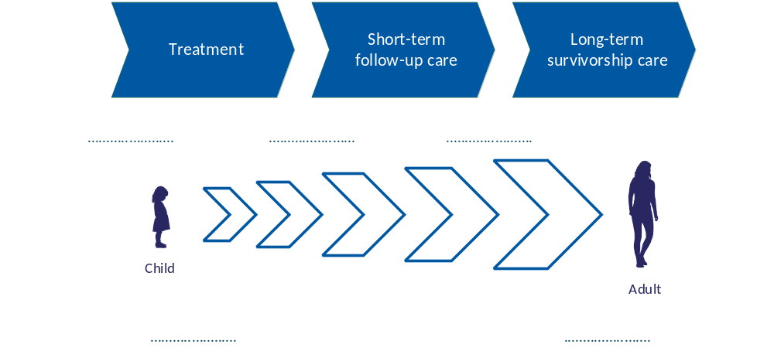
3. Overview of healthcare providers
This part shows which services and professionals are involved and outlines the scheduled clinic visits. Not all of them may be applicable.
Transition coordinator |  | Enter name
Paediatric specialist(s) |  | Enter name
Adult specialist(s) |  | Enter name
Psychologist(s) |  | Enter name
Social worker(s) |  | Enter name
Rehabilitation specialist(s) |  | Enter name
Other [specify] |  | Enter name
3a. Overview of upcoming clinic visits
Date: | Time: | Appointment with:
DD/MM/YYYY | Enter time | Enter name
DD/MM/YYYY | Enter time | Enter name
DD/MM/YYYY | Enter time | Enter name

4. Personal needs and wishes
This part leaves space to add personal needs, wishes, and expectations so that the process can be adapted to what matters most.
Preferred language | Enter preference
This is important when becoming an adult | Enter preference
This is important during the transition process | Enter preference
The healthcare providers should know that | Enter preference
Other needs and wishes | Enter preference
Information may be shared with parents/caregivers | Yes □ / No □

5. Topics to discuss
This part helps identify which topics matter most and should be discussed during the transition process. It covers different areas of life, such as health, social life, education, and daily living. The goal is to ensure smooth, consistent care, support growing independence, and promote long-term wellbeing.
Personal situation | Yes □ / No □ | e.g. education, employment, independent living, relationships
Social environment | Yes □ / No □ | e.g. family, friends, school/work, community
Social security | Yes □ / No □ | e.g. disability benefits, allowances, financial support
Changing role in my care | Yes □ / No □ | e.g. taking more responsibility in appointments, understanding your diagnosis, preparing questions for your care team
Medication management | Yes □ / No □ | e.g. remembering medication times, organizing refills
Lifestyle and prevention | Yes □ / No □ | e.g. health behaviours, self-management
Insurances | Yes □ / No □ | e.g. health insurance coverage, reimbursement of medication
Mental health | Yes □ / No □ | e.g. stress, anxiety, coping with uncertainty, support options
Fertility & sexual health | Yes □ / No □ | e.g. fertility preservation, contraception, sexual wellbeing
Practical support | Yes □ / No □ | e.g. finances, housing, transportation, benefits
Preferences for peer support | Yes □ / No □ | e.g. wanting contact with someone who has gone through a similar experience, support groups, online communities
Dealing with late effects | Yes □ / No □ | e.g. long-term physical and psychosocial consequences
Other | Yes □ / No □

6. Readiness assessment
This part outlines different ways to assess readiness for the transfer to a new care phase. A readiness assessment helps feeling confident, well-informed, and supported before moving to the next phase of care. There are multiple options to assess readiness. Not all options are freely accessible, please discuss the possibilities with your healthcare provider.
My healthcare provider and I chose for the following readiness assessment measurement method:

- An existing validated transition readiness assessment tool:

- TRAQ 6.0: The Transition Readiness Assessment Questionnaire (TRAQ) measures self-management and self-advocacy skills in youth with special health care needs who are preparing to move from paediatric to adult healthcare.  - TRANSITION-Q: The TRANSITION-Q is a clinically meaningful scale used in transition programmes with adolescents from age 12 onwards to measure and track the development of self-management skills needed to navigate their own health and healthcare.  - STARx: The STARx Questionnaire is a measure of overall transition readiness that assesses three domains in adolescents and young adults with chronic conditions: communication with medical providers, disease knowledge, and self-management.  - GYPES: The Gothenburg Young Persons Empowerment Scale (GYPES) is a 15-item questionnaire designed to measure patient empowerment across five dimensions in young persons with chronic conditions.  - Other, namely: …………………………………………………………………………………………………………………….  - We developed our own list with readiness criteria. | 
 | 
 | 
 | 
In the space below the main findings of the readiness assessment and the implications for the transition process can be summarized.

